Getting to the Great Hall – Sherfield Building

(President’s Welcome at 10.00am, Monday 2 October)

1. For directions to the South Kensington Campus, please see the Imperial College website:

<https://www.imperial.ac.uk/students/new-students/undergraduates/arrivals-and-induction/directions-to-south-kensington-campus/>

1. The entrance to the Sherfield Building is marked by the yellow circle on the map below. Take the stairs/lift up one floor, where you will find the Great Hall

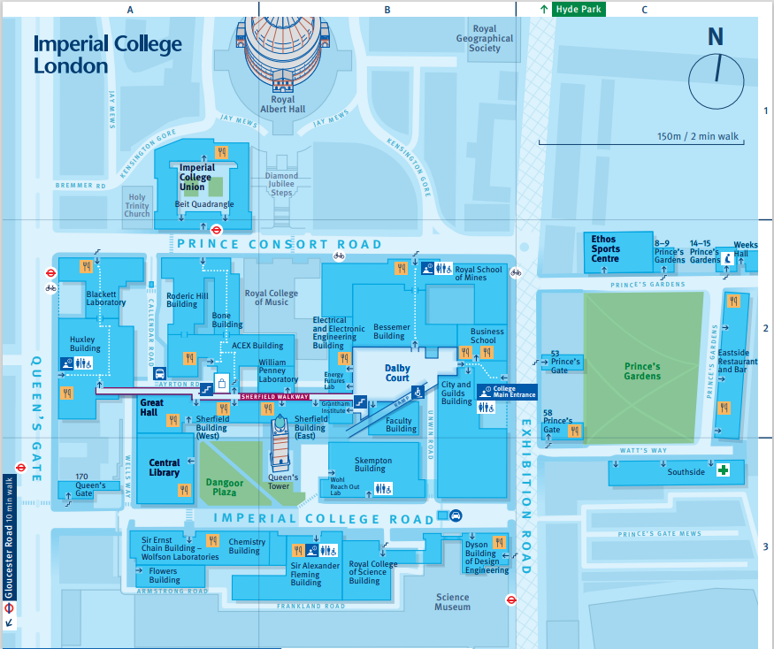

Getting to the Dyson School of Design Engineering from the Great Hall

(Imperial College Road Entrance)

1. From the Sherfield Building, cross the Dangoor Plaza to Imperial College Road.
2. Turn left onto Imperial College Road. The Dyson School of Design Engineering is the last building on the right (see picture of the entrance below).
3. Take the stairs or lift to Level 3
4. Take your seat as per the attached seating plan

